Map of Eritrea and Surrounding Countries
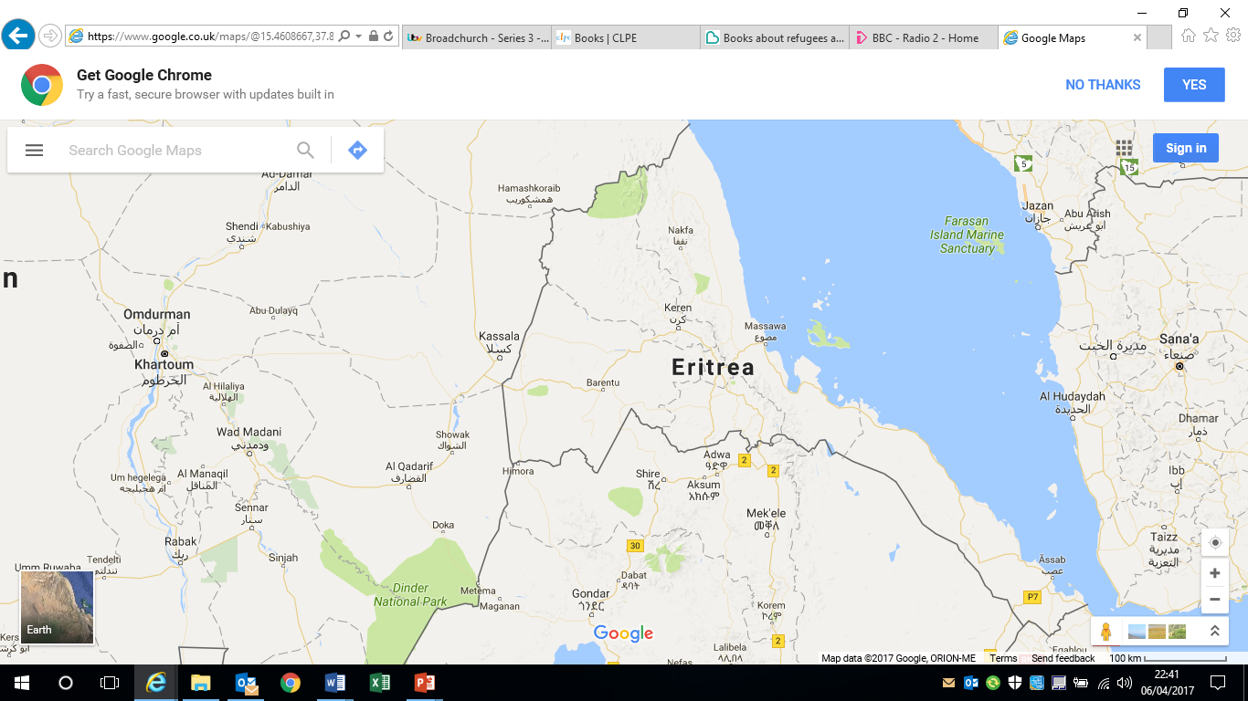
Asmara
Kassala
[Grab your reader’s attention with a great quote from the document or use this space to emphasize a key point. To place this text box anywhere on the page, just drag it.]

